4. Project Design, Forms, Buttons


Review and Preview

You have now learned the parts of a Visual Basic Express project and the three steps involved in building a project:

- Place controls on the form.
- Set control properties.
- Write desired event procedures.

Do you have some ideas of projects you would like to build using Visual Basic Express? If so, great. Beginning with this class, you will start to develop your own programming skills. In each class to come, you will learn some new features of the Visual Basic Express environment, some new controls, and elements of the BASIC language. In this class, you will learn about project design, the form and button controls, and build a complete project.

Project Design

You are about to start developing projects using Visual Basic Express. We will give you projects to build and maybe you will have ideas for your own projects. Either way, it’s fun and exciting to see ideas end up as computer programs. But before starting a project, it’s a good idea to spend a little time thinking about what you are trying to do. This idea of proper project design will save you lots of time and result in a far better project.

Proper project design is not really difficult. The main idea is to create a project that is easy to use, easy to understand, and free of errors. That makes sense, doesn’t it? Spend some time thinking about everything you want your project to do. What information does the program need? What information does the computer determine? Decide what controls you need to use to provide these sets of information. Design a nice user interface (interface concerns placement of controls on the form). Consider appearance and ease of use. Make the interface consistent with other Windows applications, if possible. Familiarity is good in Windows based projects, like those developed using Visual Basic Express.

Make the BASIC code in your event procedures readable and easy to understand. This will make the job of making later changes (and you will make changes) much easier. Follow accepted programming rules - you will learn these rules as you learn more about BASIC. Make sure there are no errors in your project. This may seem like an obvious statement, but many programs are not error-free. The Windows operating system has many errors floating around!

The importance of these few statements about project design might not make a lot of sense right now, but they will. The simple idea is to make a useful, clearly written, error-free project that is easy to use and easy to change. Planning carefully and planning ahead helps you achieve this goal. For each project built in this course, we will attempt to give you some insight into the project design process. We will always try to explain why we do what we do in building a project. And, we will always try to list all the considerations we make.
Saving a Visual Basic Express Project

When a project is created in Visual Basic Express, it is automatically saved in the location you specify. If you are making lots of changes, you might occasionally like to save your work prior to running the project. Do this by clicking the Save All button in the Visual Basic Express toolbar. Look for a button that looks like several floppy disks. (With writeable CD’s so cheap, how much longer do you think people will know what a floppy disk looks like? – many new machines don’t even have a floppy disk drive!)


Save All Toolbar Button

Always make sure to save your project before running it or before leaving Visual Basic Express.
On-Line Help

Many times, while working in the Visual Basic Express environment, you will have a question about something. You may wonder what a particular control does, what a particular property is for, what events a control has, or what a particular term in BASIC means. A great way to get help when you’re stuck is to ask someone who knows the answer. People are usually happy to help you - they like the idea of helping you learn. You could also try to find the answer in a book and there are lots of Visual Basic Express books out there! Try searching the Internet. Or, another great way to get help is to use the Visual Basic Express On-Line Help system.

Most Windows applications, including Visual Basic Express, have help files available for your use. To access the Visual Basic Express help system, click the Help item in the main menu, then View Help. At that point, you can search for the topic you need help on or scroll through all the topics. The Visual Basic Express help system is just like all other Windows help systems. If you’ve ever used any on-line help system, using the system in Visual Basic Express should be easy. If you’ve never used an on-line help system, ask someone for help. They’re pretty easy to use. Or, click on Start on your Windows task bar, then choose Help. You can use that on-line help system to learn about how to use an on-line help system!

A great feature about the Visual Basic Express on-line help system is that it is ‘context sensitive.’ What does this mean? Well, let’s try it. Start Visual Basic Express and start a new project. Go to the properties window. Scroll down the window displaying the form properties and click on the word BackColor. The word is highlighted. Press the <F1> key. A screen of information about the Form.BackColor property appears:

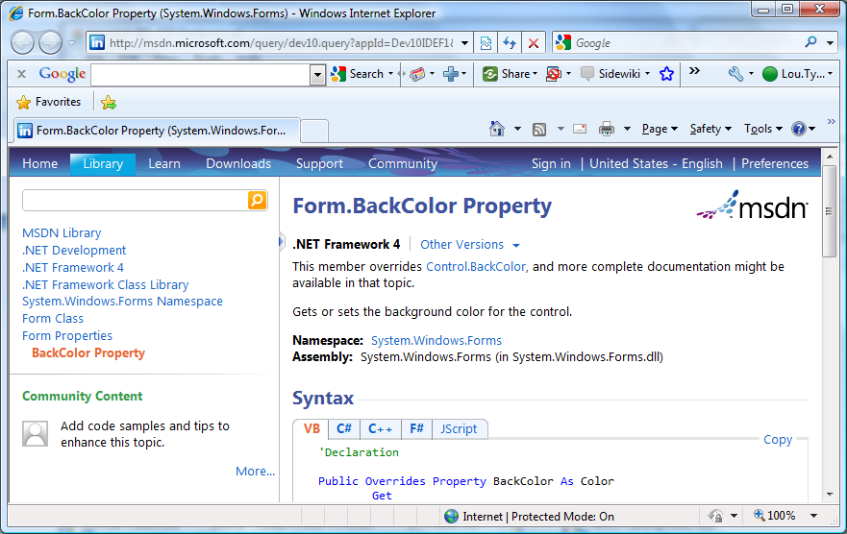

The help system has intelligence. It knows that since you highlighted the word BackColor, then pressed <F1> (<F1> has always been the key to press when you need help), you are asking for help about BackColor. Anytime you press <F1> while working in Visual Basic Express, the program will look at where you are working and try to determine, based on context, what you are asking for help about. It looks at things like highlighted words in the properties window or position of the cursor in the code window.
As you work with Visual Basic Express, you will find you will use ‘context-sensitive’ help a lot. Many times, you can get quick answers to questions you might have. Get used to relying on the Visual Basic Express on-line help system for assistance. That’s enough new material about the Visual Basic Express environment. Now, let’s look, in detail, at two important controls: the form itself and the button. Then we’ll start our study of the BASIC language and build a complete project.

The Form Control

We have seen that the form is the central control in the development of a Visual Basic Express project. Without a form, there can be no project! Let’s look at some important properties and events for the form control. The form appears when you begin a new project.
Icon
Text
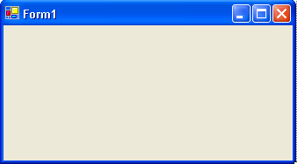

Properties

Like all controls, the form has many (over 40) properties. Fortunately, we only have to know about some of them. The properties we will be concerned with are:

Property Description
Name Name used to identify form. In this course, we will always use the default Form1 for the name.
Text Text that appears in the title bar of form.
BackColor Background color of form.
Icon Reference to icon that appears in title bar of form (we’ll look at creating icons in Class 7).
Width Width of the form in pixels.
Height Height of form in pixels.
FormBorderStyle Form can either be sizable (can resize using the mouse) or fixed size.
StartPosition Determines location of form on computer screen when application begins (we usually use a value of CenterScreen).

The form is primarily a ‘container’ for other controls. Being a container means many controls (the button control, studied next, is an exception) placed on the form will share the BackColor property. To change this behavior, select the desired control (after it is placed on the form) and change the color.

Example

To gain familiarity with these properties, start Visual Basic Express and start a new project with just a form. Set the Height and Width property values (listed under Size in the properties window) and see their effect on form size. Resize the form and notice how those values are changed in the properties window. Set the Text property. Pick a new background color using the selection techniques discussed in Class 3. Try centering the form by changing the StartPosition property (you’ll see the effect of this once you run the project). To see the effect of the BorderStyle property, set a value (either Fixed Single or Sizable; these are the only values we’ll use in this course) and run the project. Yes, you can run a project with just a form as a control! Try resizing the form in each case. Note the difference. Stop this example project.

Events

The form does support events. That is, it can respond to some user interactions. We will only be concerned with two form events in this course:

Event Description
Click Event executed when user clicks on the form with the mouse.
Load Event executed when the form first loads into the computer’s memory. This is a good place to set initial values for various properties and other project values.
FormClosing Event called when the project is ending. This is a good place to ‘clean up’ your project.

Locating form event procedures is different than locating procedures for controls - you don’t search for procedures by form name. To locate a form event in the code window, click the Object list drop-down arrow and choose (Form1 Events). Once this is selected, you can scroll through the corresponding event procedures in the procedure list.

Typical Use of Form Control

For each control in this, and following chapters, we will provide information for how that control is typically used. The usual design steps for a Form control are:

- Set the Text property to a meaningful title.
- Set the StartPosition property (in this course, this property will almost always be set to CenterScreen)
- Set the FormBorderStyle to some value. In this course, we will mostly use FixedSingle forms.
- Write any needed initialization code in the form’s Load event. To access this event in the Code window, Form1 Events (assumes your form is named Form1), then the Load event.
- Write any needed finalization code in the form’s FormClosing event.

Button Control

The button is one of the more widely used Visual Basic Express controls. Buttons are used to start, pause, or end particular processes. The button is selected from the toolbox. It appears as:

In Toolbox: On Form (default properties):

Properties

A few useful properties for the button are:

Property Description
Name Name used to identify button. Three letter prefix for button names is btn.
Text Text (caption) that appears on the button.
TextAlign How the caption text is aligned on the button.
Font Sets style, size, and type of caption text.
BackColor Background color of button.
ForeColor Color of text on button.
Left Distance from left side of form to left side of button (referred to by X in properties window).
Top Distance from top side of form to top side of button (referred to by Y in properties window).
Width Width of the button in pixels.
Height Height of button in pixels.
Enabled Determines whether button can respond to user events (in run mode).
Visible Determines whether the button appears on the form (in run mode).
Example

Start Visual Basic Express and start a new project. Put a button on the form. Move the button around and notice the changes in X and Y properties (listed under Location in the properties window). Resize the button and notice how Width and Height change. Set the Text property. Change BackColor and ForeColor properties.

Many controls, in addition to the button, have a Font property, so let’s take a little time to look at how to change it. Font establishes what the Text looks like. When you click on Font in the properties window, a button with something called an ellipsis will appear on the right side of the window:



Click this button and a Font Window will appear:
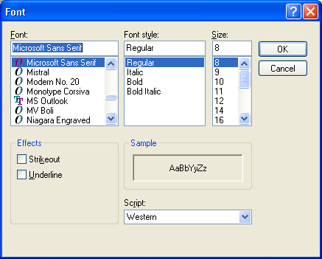
With this window, you can choose three primary pieces of information: Font, Font Style, and Size. You can also have an underlined font. This window lists information about all fonts stored on your computer. To set the Font property, make your choices in this window and click OK. Try different fonts, font styles, and font size for the button Text property.

Two other properties listed for the button are Enabled and Visible. Each of these properties can either be True (On) or False (Off). Most other controls also have these properties. Why do you need these?

If a control’s Enabled property is False, the user is unable to access that control. Say you had a stopwatch project with a Start and Stop button:

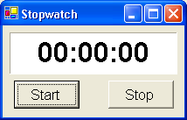

You want the user to click Start, then Stop, to find the elapsed time. You wouldn’t want the user to be able to click the Stop button before clicking the Start button. So, initially, you would have the Start button’s Enabled property set to True and the Stop button’s Enabled property set to False. This way, the user can only click Start. Once the user clicked Start, you would swap property values. That is, make the Start button’s Enabled property False and the Stop button’s Enabled property True. That way, the user could now only click Stop.

The effects of a False Enabled property are only evident when Visual Basic Express is in run mode. When a button is not Enabled (Enabled is False), it will appear ‘hazy’ and the user won’t be able to click it. When Stop is not Enabled on the stopwatch, it looks like this:

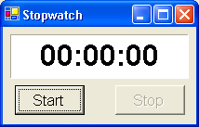

So, use the Enabled property when you want a control on the form to be temporarily disabled. This is a decision made in the project design process we discussed earlier.

The Visible property is a bit more drastic. When a control’s Visible property is set to False (its default value is True), the control won’t even be on the form! Now, why would we want a control we just placed on the form, set properties for, and wrote event procedures for, to be invisible? The answer is similar to that for the Enabled property. Many times in a project, you will find you want a control to temporarily go away. Remember the Sample project in Class 1 where check boxes controlled whether foods were displayed or not. The display of the foods was controlled via the picture box control’s Visible property. Or, in the little stopwatch example, instead of setting a button’s Enabled property to False to make it ‘unclickable,’ we could just set the Visible property to False so it doesn’t appear on the form at all. Either way, you would obtain the desired result. This is another project design decision. One more thing - like the Enabled property, the effects of Visible being False are only evident in run mode. This makes sense. It would be hard to design a project with invisible controls!

Now, play with the Enabled and Visible properties of the button in the example you have been working with. Once you set either property, run the project to see the results. Note with Enabled set to False, you can’t click the button. Note with Visible set to False, the button isn’t there. When done, stop the example project.

Events

There is only one button event of interest, but it is a very important one:

Event Description
Click Event executed when user clicks on the button with the mouse.

Every button will have an event procedure corresponding to the Click event.

Typical Use of Button Control

The usual design steps for a button control are:

- Set the Name and Text property.
- Write code in the button’s Click event.
- You may also want to change the Font, Backcolor and Forecolor properties.

BASIC - The First Lesson

At long last, we are ready to get into the heart of a Visual Basic Express project - the BASIC language. You have seen that, in a Visual Basic Express project, event procedures are used to connect control events to actual actions taken by the computer. These event procedures are written using BASIC. So, you need to know BASIC to know Visual Basic Express. In each subsequent class in this course, you will learn something new about the BASIC language.

Event Procedure Structure

You know, by now, that event procedures are viewed in the Visual Basic Express code window. Each event procedure has the same general structure. First, there is a header line of the form:

Private Sub ControlName_EventName(ByVal sender As System.Object, ByVal e As System.EventArgs) Handles ControlName.EventName

This tells us we are working with a Private (only accessible from our form), Subroutine (another name for a event procedure) that is executed when the event EventName occurs for the control ControlName. Makes sense, doesn’t it? Again, for now we will ignore the information contained in the parentheses.

The event procedure code begins following the header line. The event procedure code is simply a set of line-by-line instructions to the computer, telling it what to do. The computer will process the first line, then the second, then all subsequent lines.

Code is processed in a procedure until it reaches the event procedure footer line:

End Sub

The event procedure code is written in the BASIC language. BASIC is a set of keywords and symbols that are used to make the computer do things. There is a lot of content in BASIC and we’ll try to look at much of it in this course. Just one warning at this point. We’ve said it before, but it’s worth saying again. Computer programming requires exactness - it does not allow errors! The Visual Basic Express environment can point out some errors to you, but not all. You must especially be exact when typing in event procedures. Good typing skills are a necessity in the computer age. As you learn Visual Basic Express programming, you might like also to improve your typing skills using some of the software that’s available for that purpose. The better your typing skills, the fewer mistakes you will make in building your Visual Basic Express applications.

Assignment Statement

The simplest, and most used, statement in BASIC is the assignment statement. It has this form:

LeftSide = RightSide

The symbol = is called the assignment operator. You may recognize this symbol as the equal sign you use in arithmetic, but it’s not called an equal sign in computer programming. Why is that?

In an assignment statement, we say whatever is on the left side of the assignment statement is replaced by whatever is on the right side. The left side of the assignment statement can only be a single term, like a control property. The right side can be just about any legal BASIC expression. It might have some math that needs to be done or something else that needs to be evaluated. If there are such evaluations, they are completed before the assignment. We are talking in very general terms right now and we have to. The idea of an assignment statement will become very obvious as you learn just a little more BASIC.

Property Types

Recall a property describes something about a control: size, color, appearance. Each property has a specific type depending on the kind of information it represents. When we use the properties window to set a value in design mode, Visual Basic Express automatically supplies the proper type. If we want to change a property in an event procedure using the BASIC assignment statement, we must know the property type so we can assign a properly typed value to it. Remember we use something called ‘dot notation’ to change properties in run mode:

ControlName.PropertyName = PropertyValue

ControlName is the Name property assigned to the control, PropertyName is the property name, and PropertyValue is the new value we are assigning to PropertyName. We will be concerned with four property types.

The first property type is the integer type. These are properties that are represented by whole, non-decimal, numbers. Properties like the Top, Left, Height, and Width properties are integer type. So, if we assign a value to an integer type property, we will use integer numbers. As an example, to change the width property of a form to 1,100 pixels, we would write in BASIC:

Me.Width = 1100

Recall the keyword Me is used to refer to the form. This says we replace the current Width of the form with the new value of 1100. Notice you write 1,100 as 1100 in BASIC - we can’t use commas in large numbers.

A second property type involves colors. We need this to set properties like BackColor. Fortunately, Visual Basic Express has a set of built-in colors to choose from. To set a control color (described by ColorPropertyName), we type:

ControlName.ColorPropertyName = Color.ColorName

As soon as we type the word Color and a dot on the right side of the assignment statement, a entire list of color names to choose from magically appears. To change the form background color to blue, use:

Me.BackColor = Color.Blue

Another property type is the Boolean type. It takes its name from a famous mathematician (Boole). It can have two values: True or False. We saw that the Enabled and Visible properties for the button have Boolean values. So, when working with Boolean type properties, we must insure we only assign a value of True or a value of False. To make a form disappear (not a very good thing to do!), we would use the assignment statement:

Me.Visible = False

This says the current Visible property of the form is replaced by the Boolean value False. We could make it come back with:

Me.Visible = True

The last property type we need to look at here is the string type. Properties of this type are simply what the definition says - strings of characters. A string can be a name, a string of numbers, a sentence, a paragraph, any characters at all. And, many times, a string will contain no characters at all (an empty string). The Text property is a string type property. We will do lots of work with strings in Visual Basic Express, so it’s something you should become familiar with. When assigning string type properties, the only trick is to make sure the string is enclosed in quotes (“”). You may tend to forget this since string type property values are not enclosed in quotes in the properties window. To give our a form a caption in the title bar, we would use:

Me.Text = “This is a caption in quotes”

This assignment statement says the Text property of the form is replaced by (or changed to) the string value on the right side of the statement. You should now have some idea of how assignment statements work.

Comments

When we talked about project design, it was mentioned that you should follow proper programming rules when writing your BASIC code. One such rule is to properly comment your code. You can place non-executable statements (ignored by the computer) in your code that explain what you are doing. These comments can be an aid in understanding your code. They also make future changes to your code much easier.

To place a comment in your code, use the comment symbol, an apostrophe (‘). This symbol is to the left of the <Enter> key on most keyboards, not the key next to the 1 key. Anything written after the comment symbol will be ignored by the computer. You can have a comment take up a complete line of BASIC code, like this:

‘Change form to blue
Me.BackColor = Color.Blue

Or, you can place the comment on the same line as the assignment statement:

Me.BackColor = Color.Blue ‘Makes form blue

You, as the programmer, should decide how much you want to comment your code. We will try in the projects provided in this course to provide adequate comments. Now, on to the first such project.
Project - Form Fun

Project Design

In this project, we will have a little fun with form properties using buttons. We will have a button that makes the form grow, one that makes the form shrink, and two buttons that change the form color. We’ll even have a couple of buttons that make the other buttons disappear and reappear. This project is saved as FormFun in the course projects folder (\BeginVBE\BVBE Projects).

Place Controls on Form

Start a new project in Visual Basic Express. Size the form so six buttons will fit on the form. Place six buttons on the form. Resize and move the buttons around until the form looks something like this:

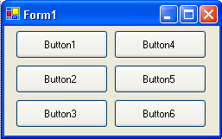

If you’ve used Windows applications for a while, you have probably used the edit feature known as Copy and Paste. That is, you can copy something you want to duplicate, move to the place you want your copy and then paste it. This is something done all the time in word processing. You may have discovered, in playing around with Visual Basic Express, that you can copy and paste controls. Try it here with the button controls and in other projects if you like. It works pretty nicely.

Set Control Properties

Set the control properties using the properties window. Remember that to change the selected control in the properties window, you can either use the controls list at the top of the window or just click on the desired control. For project control properties, we will always list controls by their default names (those assigned by Visual Basic Express when the control is placed on the form).

Form1 Form:
Property Name Property Value
StartPosition CenterScreen
Text Form Fun

Button1 Button:
Property Name Property Value
Name btnShrink
Text Shrink Form

Button2 Button:
Property Name Property Value
Name btnGrow
Text Grow Form

Button3 Button:
Property Name Property Value
Name btnHide
Text Hide Buttons

Button4 Button:
Property Name Property Value
Name btnRed
Text Red Form

Button5 Button:
Property Name Property Value
Name btnBlue
Text Blue Form

Button6 Button:
Property Name Property Value
Name btnShow
Text Show Buttons
Visible False

You can change other properties if you want - maybe change the Font property of the buttons. When you’re done setting properties, your form should resemble this:

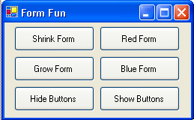
btnShrink
btnGrow
btnHide
btnRed
btnBlue
btnShow
What we have are six buttons, two to change the size of the form, two to change form color, one to make buttons go away, and one to make buttons reappear. Notice the Show Buttons button has a Visible property of False. We don’t want it on the form at first, since the buttons will already be there. When we make the buttons go away (by changing their Visible property) by clicking the Hide Buttons control, we will make the Show Buttons button appear. Makes sense, doesn’t it? But, why is the Show Buttons button there if its Visible property is False? Remember a False Visible property will only be seen in run mode.

Write Event Procedures

We have six buttons on our form. We need to write code for the Click event procedure for each of these buttons. We’ll also want to write a Click event procedure for the form - we’ll explain why. We have a button on the form that makes the form shrink. What if we shrink it so much, we can’t click on the button to make it grow again? We can avoid that by allowing a click on the form to also grow the form. This ‘thinking ahead’ is one of the project design concepts we talked about.

For each event procedure, you use the code window. Select the control in the object list and the event in the procedures list. Then click in the region between the header line and footer line and start typing code. It’s that easy. But, again, make sure you type in everything just as written in these notes. You must be exact!

First, let’s type the btnShrink_Click event procedure. In this procedure, we decrease the form height by 10 pixels and decrease the form width by 10 pixels:

Private Sub btnShrink_Click(ByVal sender As System.Object, ByVal e As System.EventArgs) Handles btnShrink.Click
'Shrink the form
'Decrease the form height by 10 pixels

Me.Height = Me.Height - 10
'Decrease the form width by 10 pixels
Me.Width = Me.Width - 10
End Sub

Before looking at the other event procedures, let’s look a bit closer at this one since it uses a few ideas we haven’t clearly discussed. This is the event procedure executed when you click on the button marked Shrink Form. You should easily recognize the comment statements. The non-comment statements change the form height and width. Look at the statement to change the height:

Me.Height = Me.Height - 10

Recall how the assignment operator (=) works. The right side is evaluated first. So, 10 is subtracted (using the - sign) from the current form height. That value is assigned to the left side of the expression, Me.Height. The result is the form Height property is replaced by the Height property minus 10 pixels. After this line of code, the Height property has decreased by 10 and the form will appear smaller on the screen.

This expression also shows why we call the assignment operator (=) just that and not an equal sign. Anyone can see the left side of this expression cannot possibly be equal to the right side of this expression. No matter what Me.Height is, the right side will always be 10 smaller than the left side. But, even though this is not an equality, you will often hear programmers read this statement as “Me.Height equals Me.Height minus 10,” knowing it’s not true! Remember how assignment statements work as you begin writing your own programs.

Now, let’s look at the other event procedures. The btnGrow_Click procedure increases form height by 10 pixels and increases form width by 10 pixels:

Private Sub btnGrow_Click(ByVal sender As System.Object, ByVal e As System.EventArgs) Handles btnGrow.Click
'Grow the form
'Increase the form height by 10 pixels
Me.Height = Me.Height + 10
'Increase the form width by 10 pixels
Me.Width = Me.Width + 10
End Sub
The btnRed_Click event procedure changes the form background color to red:

Private Sub btnRed_Click(ByVal sender As System.Object, ByVal e As System.EventArgs) Handles btnRed.Click
'Make form red
Me.BackColor = Color.Red
End Sub

while the btnBlue_Click event procedure changes the form background color to blue:

Private Sub btnBlue_Click(ByVal sender As System.Object, ByVal e As System.EventArgs) Handles btnBlue.Click
'Make form blue
Me.BackColor = Color.Blue

End Sub

The btnHide_Click event procedure is used to hide (set the Visible property to False) all buttons except btnShow, which is made Visible:

Private Sub btnHide_Click(ByVal sender As System.Object, ByVal e As System.EventArgs) Handles btnHide.Click
'Hide all buttons but btnShow
btnGrow.Visible = False
btnShrink.Visible = False
btnHide.Visible = False
btnRed.Visible = False
btnBlue.Visible = False
'Show btnShow button
btnShow.Visible = True
End Sub
and the btnShow_Click event procedure reverses these effects:

Private Sub btnShow_Click(ByVal sender As System.Object, ByVal e As System.EventArgs) Handles btnShow.Click
'Show all buttons but btnShow
btnGrow.Visible = True
btnShrink.Visible = True
btnHide.Visible = True
btnRed.Visible = True
btnBlue.Visible = True
'Hide btnShow button
btnShow.Visible = False

End Sub

Lastly, the Form1_Click event procedure is also used to ‘grow’ the form, so it has the same code as btnGrow_Click. Recall to ‘find’ this procedure, choose (Form1 Events) from the Object list box in the code window, then Click from the procedures box:

Private Sub Form1_Click(ByVal sender As Object, ByVal e As System.EventArgs) Handles MyBase.Click
'Grow the form
'Increase the form height by 10 pixels
Me.Height = Me.Height + 10
'Increase the form width by 10 pixels
Me.Width = Me.Width + 10

End Sub

Save your project by clicking the Save All button (the multiple floppy disks button) in the toolbar.

You should easily be able to see what’s going on in each of these procedures. Pay special attention to how the Visible property was used in the btnHide and btnShow button click events. Notice too that many event procedures are very similar in their coding. For example, the Form1_Click event is identical to the btnGrow_Click event. This is often the case in Visual Basic Express projects. We encourage the use of editor features like Copy and Paste when writing code. To copy something, highlight the desired text using the mouse - the same way you do in a word processor. Then, select Edit in the Visual Basic Express main menu, then Copy. Move the cursor to where you want to paste. You can even move to other event procedures. Select Edit, then Paste. Voila! The copy appears. The pasted text might need a little editing, but you will find that copy and paste will save you lots of time when writing code. And, this is something you’ll want to do since you probably have noticed there’s quite a bit of typing in programming, even for simple project such as this. Also useful are Find and Replace editor features. Use them when you can.

The Intellisense feature of Visual Basic Express is another way to reduce your typing load and the number of mistakes you might make. While you are writing BASIC in the code window, at certain points little boxes will pop up that display information that would logically complete the statement you are working on. This way, you can select the desired completion, rather than type it.
Run the Project

Go ahead! Run your project - click the Start button on the Visual Basic Express toolbar. If it doesn’t run properly, the only suggestion at this point is to stop the project, recheck your typing, and try again. We’ll learn ‘debugging’ techniques in the next class. Here’s a run I made where I grew the form and made it red:

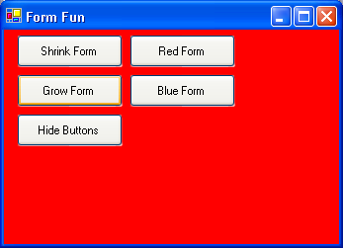

Try all the buttons. Grow the form, shrink the form, change form color, hide the buttons, make the buttons reappear. Make sure you try every button and make sure each works the way you want. Make sure clicking the form yields the desired result. This might seem like an obvious thing to do but, for large projects, sometimes certain events you have coded are never executed and you have no way of knowing if that particular event procedure works properly. This is another step in proper project design - thoroughly testing your project. Make sure every event works as intended. When done trying out this project, stop it (click the Visual Basic Express toolbar Stop button).

Other Things to Try

For each project in this course, we will offer suggestions for changes you can make and try. Modify the Shrink Form and Grow Form buttons to make them also move the form around the screen (use the Left and Top properties). Change the form color using other color values. Change the Hide Buttons button so that it just sets the buttons’ Enabled property to False, not the Visible property. Similarly, modify the Show Buttons button.
Summary

Congratulations! You have now completed a fairly detailed (at least there’s more than one control) Visual Basic Express project. You learned about project design, saving projects, details of the form and button controls, and how to build a complete project. You should now be comfortable with the three steps of building a project: placing controls, setting properties, and writing event procedures. We will continue to use these steps in future classes to build other projects using new controls and more of the BASIC language.

